**Epyx FastLoad Cartridge for the C64 Rev. 2**

**Module Description**

This is a cartridge PCB, which is suitable for the Epyx FastLoad software.

This software can be obtained here: <https://rr.pokefinder.org/wiki/Epyx_FastLoad>

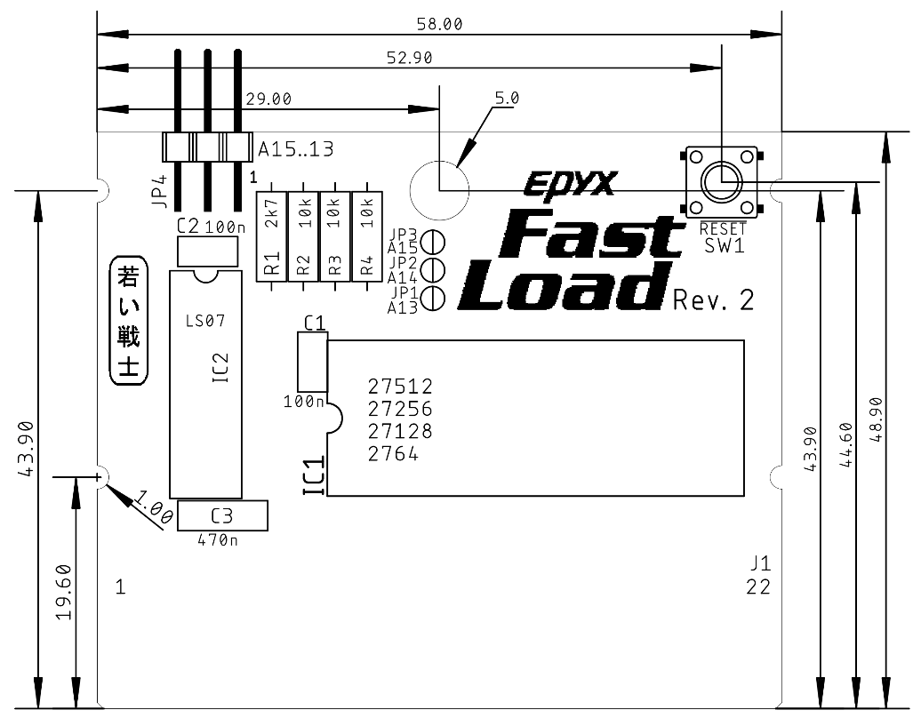

Figure 1: Dimensions

The circuit is based on a schematic found at the source, which was mentioned before.

A RESET button was added to this circuit and solder bridges (JP1 to JP3) for configuring the cartridge for being used with 27C64, 27C128, 27C256 and 27C512 EPROMs for a greater part availability.

|  |  |  |  |
| --- | --- | --- | --- |
| **EPROM** | **Jumper** | | |
| JP3 = A15 | JP2 = A14 | JP1 = A13 |
| 27C64 | open | open | open |
| 27C128 | open | open | close |
| 27C256 | open | close | close |
| 27C512 | close | close | close |

The software is programmed to the EPROM offset address 0x0000 (hex).

The dimensions are equal to the dimensions of the Versa64Cart. Notches for the Stumpy Cartridge Case were added in Rev. 2.

The memory slot can be selected with a jumper (JP4). Leave JP1..3 open and set the jumpers on the pins accordingly.

# Revision History

## Rev. 0

* Prototype, fully functional

## Rev. 1

* Board Revision
* Added JP4

## Rev. 2

* Notches added for fitting the tfw8bit.com [Stumpy Cartridge Case](https://www.thefuturewas8bit.com/shop/commodore/c64/c64romcart.html)